OOP Assignment Documentation 9th Assignment
Name: Kazim Ali
Neptun: Z0W7JF
Email: alikazimodamas123@gmail.com
Group: 9
Date: 9th February
Task:
Implement the bag type which contains integers. Represent the bag as a sequence of (element, frequency) pairs. Implement as methods: inserting an element, removing an element, returning the frequency of an element, returning the number of elements which occur only once in the bag (suggestion: store the number of these elements and update it when the bag changes), printing the bag. Lecture code cannot be submitted.
Bag Type
Set of values:
Bag: <Tuple<int,int>>

Operations:
- Add:
Since the bag is list of tuples of integers, the tuple is having Item1 as element and Item2 as its frequency.
Formally: A = (b: Bag, a ϵ Tuple<int,int>)
Pre = (b = b` ∧ a = a` )
Post = b = b ∪ <a>
- Remove:
Removing an element from the bag. It is same as insertion, but we remove at place of addition.
A = (b: Bag, a ϵ Tuple<int,int>)
Pre = (b = b` ∧ a = a` )
Post = b = b \ <a>

- Frequency:
It returns the frequency of an element in the bag.
A = (b: Bag, a ϵ ℕ)
Pre = (b = b` ∧ a = a` )
Post = (a = bag[a.Item2])

- Return frequency of singular elements:
It returns the frequency of elements that are occur only once in the bag.
A = (b: Bag)
Pre = (b = b` )
Post = (Pre ∧ a = i = 0…bag. length 1)
Cond(i)
Cond(i) := i.Item2 == 1

Representation:
One-dimensional list (Vec) of Tuple<Element : ℕ ,Frequency: ℕ > is needed to store bag elements. Bag as a Vec in C#.
Vec: 0 . . . m : Tupleℕ, > 0...m

Implementation:
- Insertion: Inserting an element. Here bag is represented by vec and m stands for the size of the bag. The max is max element inside the bag.

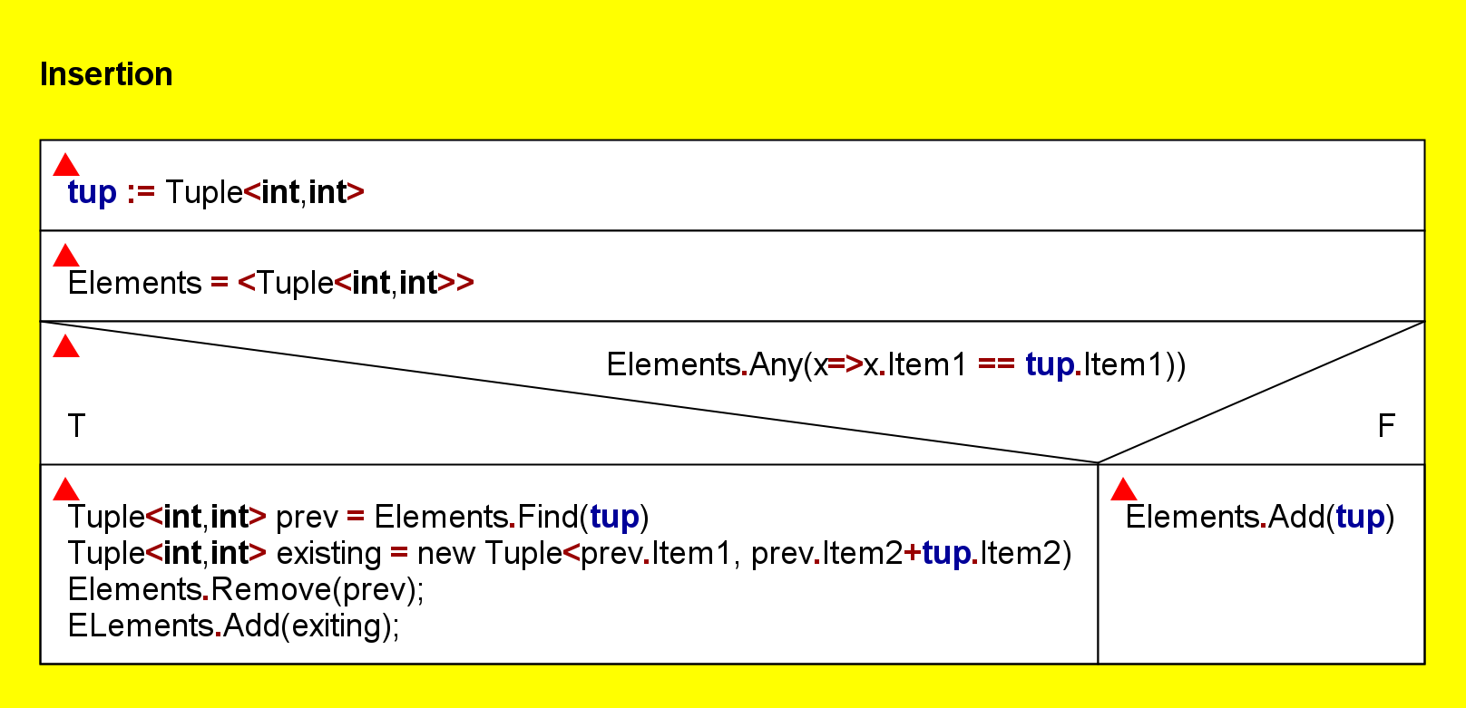

- Removing: Removing is same as insertion but we subtract the element instead of adding it.
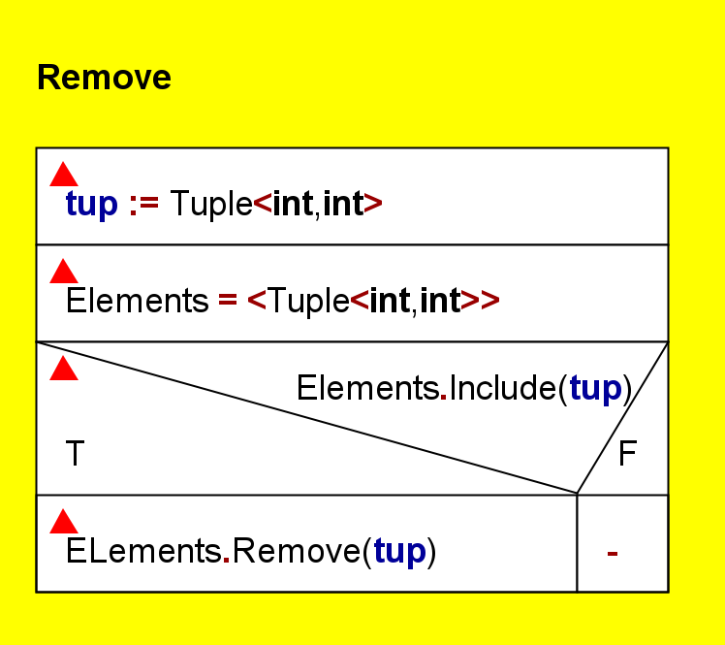

- Frequency:
This method checks the frequency in the bag and returns its value.
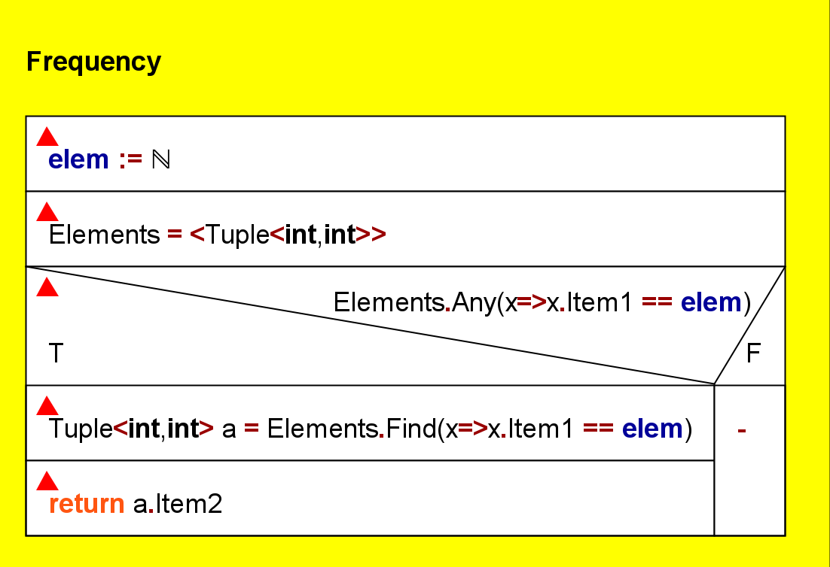

- Singular Elements: It returns the count of singular elements in the bag.
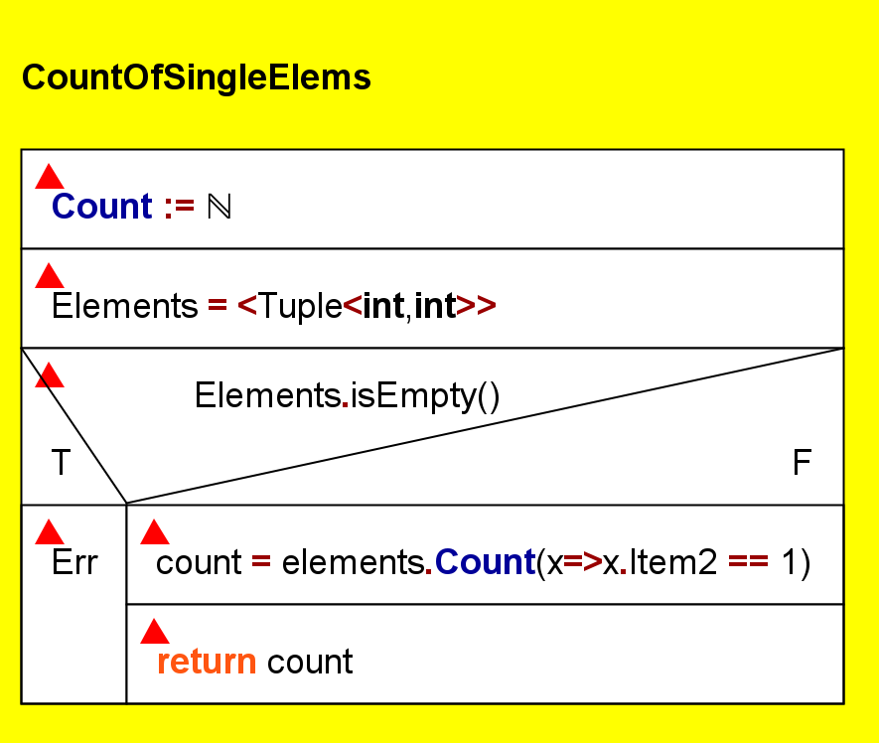

Testing:
Testing the operations (black box testing)
- Creating a bag with different sizes.
- we can create any sized bag (1…n) n ϵ Z
- Getting/Removing entry of the bag
- Getting/Removing an element from inside the bag.
- Getting/Removing an element from outside the bag.

- Getting Frequency of elements and count of single elements in the bag
- Element frequency/ single element counts from inside the range and outside the range of the bag.
- When illegal element is given.
Testing based on the code (white box testing)

- AddCheck :
This method checks whether the add method of the class bag updates the bag correctly or not, ensuring that the bag is having the correct value after inputting it.
- RemoveCheck:
This method tests the removal of an item from the bag and it also ensures that the remaining elements are correct.
- FreqCheck: Validates the frequency of an element inside the bag, which is calculated accurately after adding tuples with different keys and frequencies. It also checks the implementation of non-existing element inside the bag.
- SingleFreqCheck: Ensures the count of single elements inside the bag is updated correctly.

